1. Singleton problem in context of Serialization, can be handle by “**readResolve() Method**”.
2. When we deserialize, the following method is called  
   Object readResolve(){} 🡺 Return type is upto you.
3. 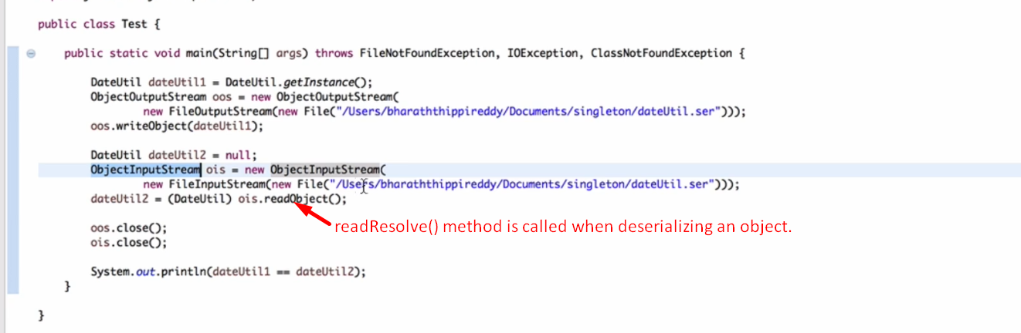
4. 